MINOR PROJECT REPORT

Infrastructure Deployment & Basic Logging on Microsoft Azure

Student Details
- Name: Anushriya Sahu
- ERP / Roll Number: 6604680
- Group Number: G1

Introduction
This Minor Project focuses on deploying a small-scale enterprise cloud infrastructure using Microsoft Azure.
The project simulates a real-world company environment where students act as the Infrastructure Team, responsible for deploying servers, networking, and logging mechanisms.
This phase intentionally avoids any form of security hardening so that vulnerabilities and misconfigurations can later be exploited and mitigated during the Major Project phase.

Project Objective
The objective of this project is to:
- Design and deploy a functional mini-company infrastructure on Microsoft Azure
- Deploy three Linux-based virtual machines with defined enterprise roles
- Configure basic logging mechanisms only
- Enable centralized log collection using SIEM
- Prepare an intentionally unsecured environment for cyber-attacks and SOC analysis

Resource Group Configuration
As per project compliance rules, exactly one Azure Resource Group was created.
- Resource Group Name: Skygrid-Solutions
- Region: Central India
All Azure resources including:
- Virtual Machines
- Virtual Network
- Subnets
- Network Security Groups
- Public IP addresses
were created inside this Resource Group only.
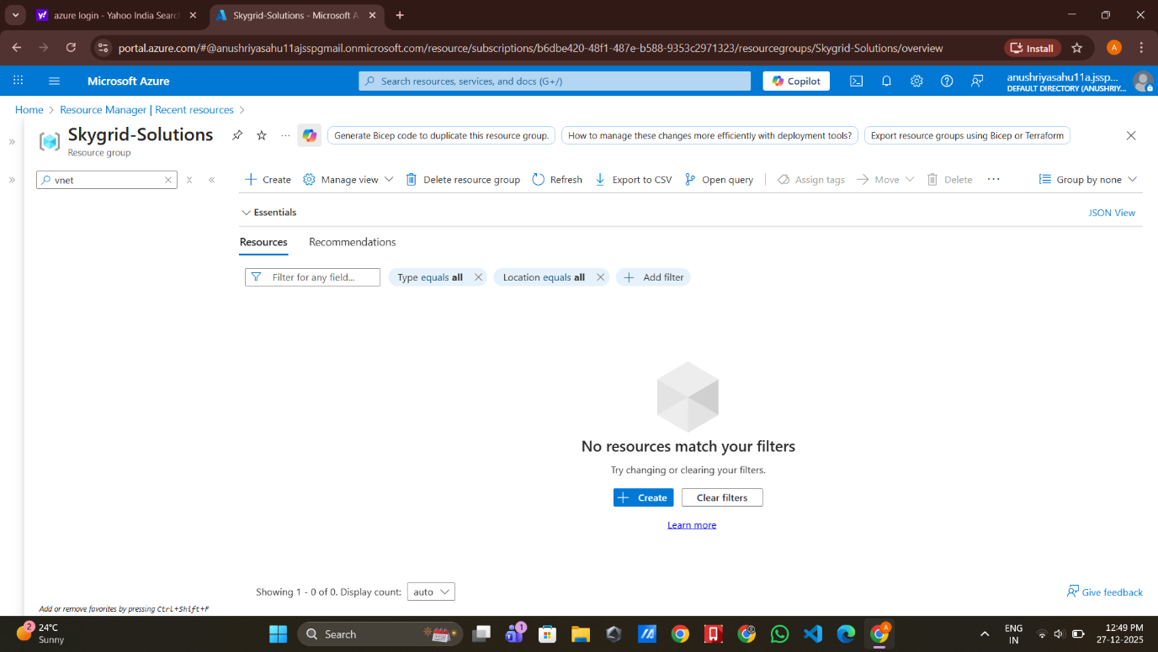
Azure Portal showing the Resource Group Skygrid-Solutions with student account name visible.

Network Architecture Design

4.1 Virtual Network Creation
A Virtual Network was created to host the company infrastructure.
- VNet Name: Skygrid-Solutions-VNet
- Address Space: 10.0.0.0/16

4.2 Subnet Configuration
Two subnets were created to separate internal and external services.
Subnet Name | Address Range | Purpose
Inernal-Subnet | 10.0.1.0/24 | Internal services and SIEM
DMZ-Subnet | 10.0.2.0/24 | Public-facing web server
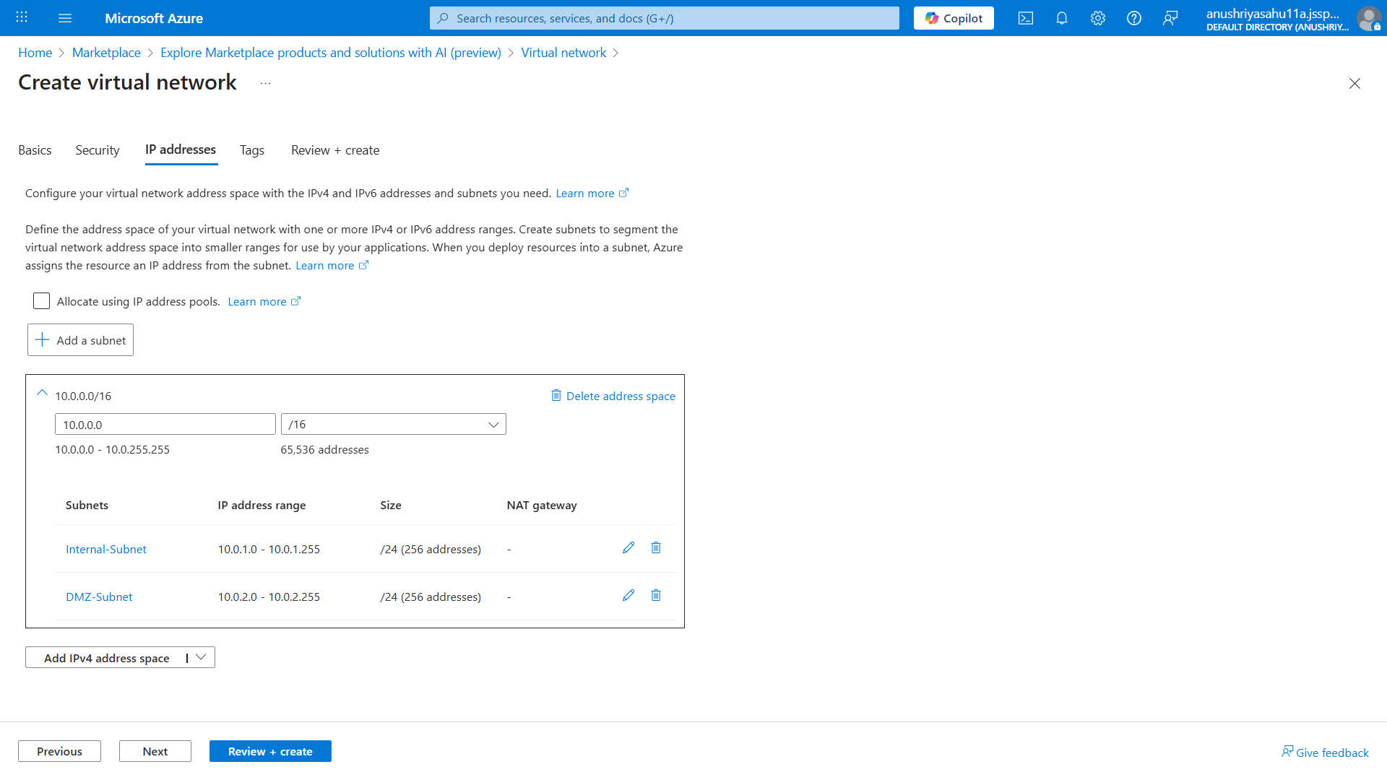
Virtual Network showing Internal and DMZ subnets under the Skygrid-Solutions resource group.

Network Security Groups (Basic Configuration)
Basic Network Security Groups (NSGs) were created to allow required traffic without any hardening.

Internal Subnet NSG
- SSH (Port 22) – Allowed from any source
- All outbound traffic – Allowed

DMZ Subnet NSG
- SSH (Port 22) – Allowed
- HTTP (Port 80) – Allowed
- HTTPS (Port 443) – Allowed
- All outbound traffic – Allowed
⚠️ No restrictive firewall rules were applied.
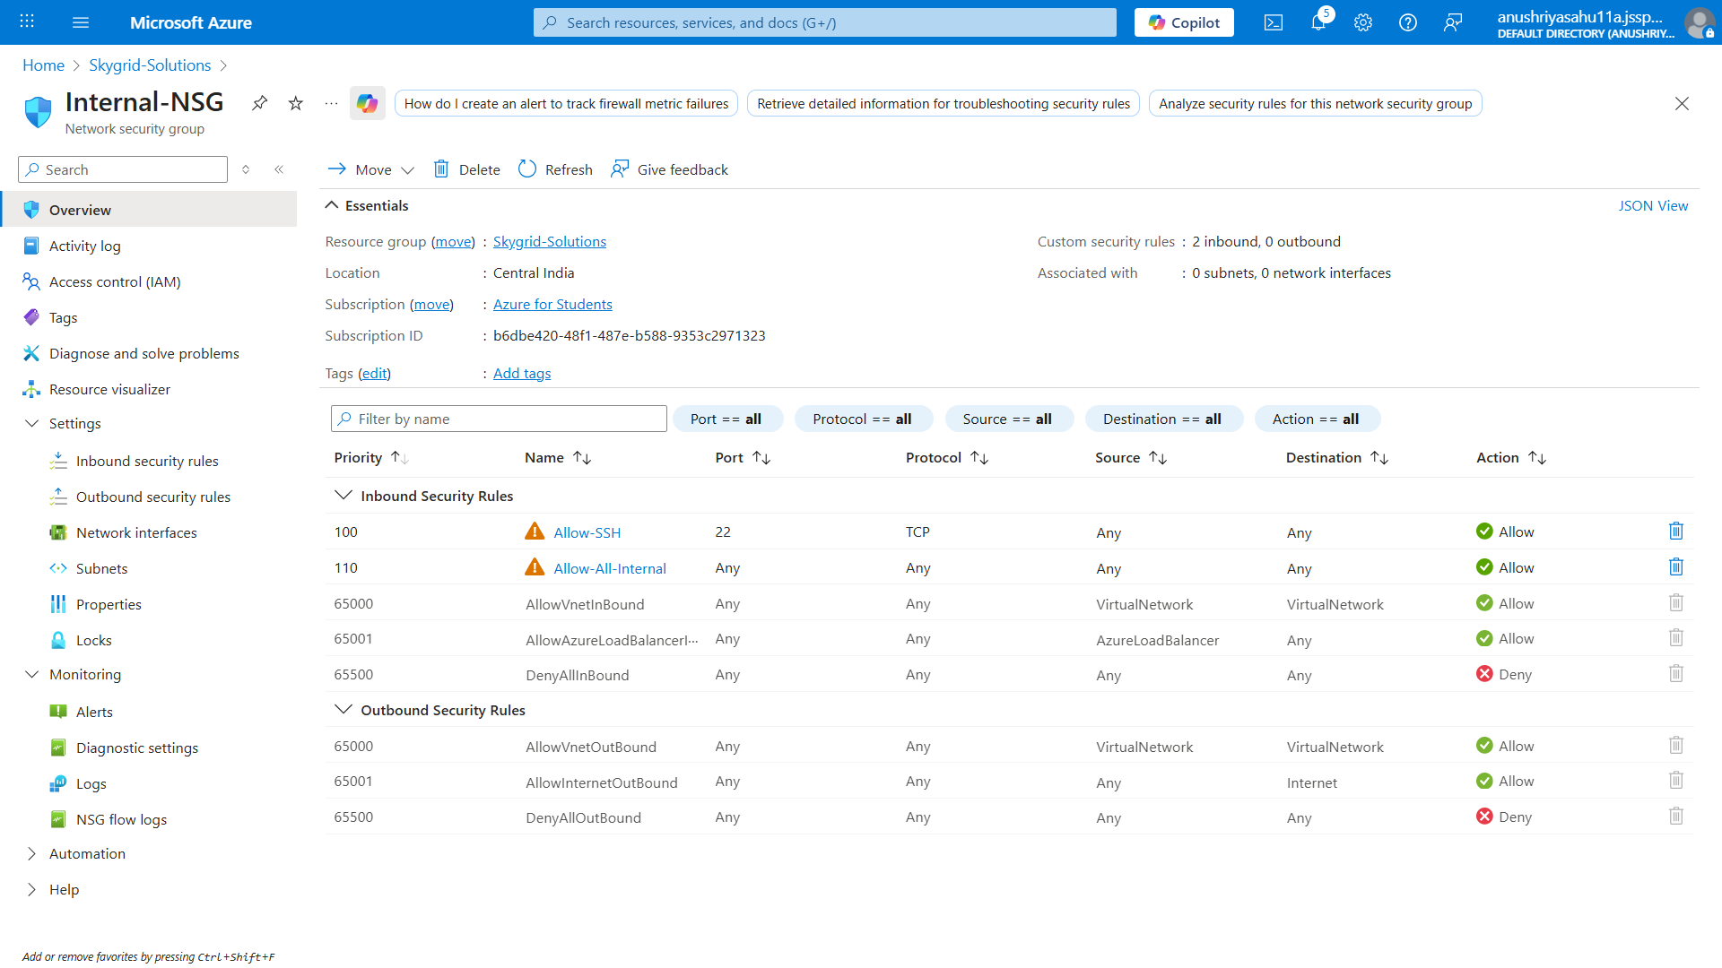
Internal-NSG showing unrestricted inbound and outbound access.
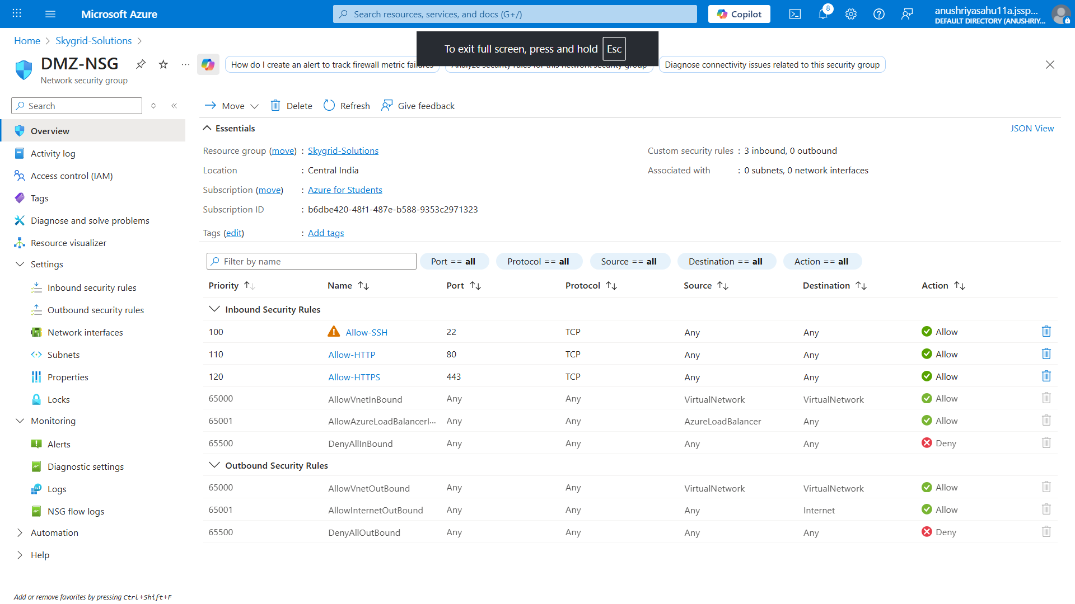
DMZ-NSG showing unrestricted inbound and outbound access.

Virtual Machine Deployment
Exactly three Linux virtual machines were deployed as required.

6.1 Common VM Configuration
- Operating System: Ubuntu 22.04 LTS
- Authentication: Username and Password
- Public IP Address: Enabled
- Resource Group: Skygrid-Solutions

6.2 VM Inventory

VM Name | OS | Purpose | Private IP | Subnet | Size
VM-Internal-Server | Ubuntu | FreeIPA + File Server | 10.0.1.x | Internal | B1s
VM-Web-Server | Ubuntu | Web Server | 10.0.2.x | DMZ | B1s
VM-SIEM | Ubuntu | SIEM + Analyst | 10.0.1.x | Internal | B2s

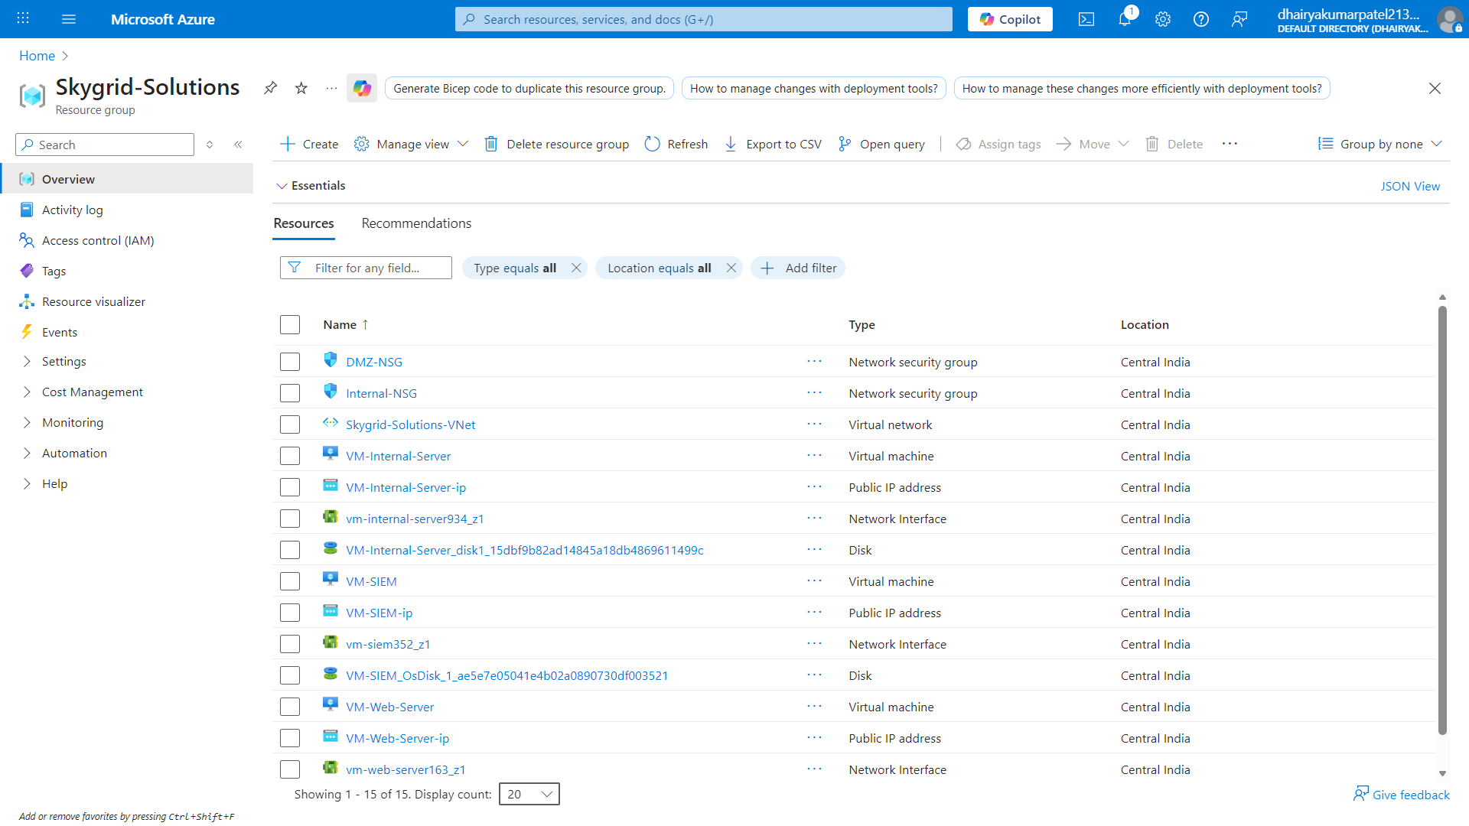
Azure Portal showing all three virtual machines deployed in the correct subnets.

Server Roles and Configuration

7.1 VM 1 – Internal Server
Roles Implemented:
- FreeIPA (LDAP + Kerberos)
- Samba File Server
- Internal service hosting
This server simulates corporate identity management and internal file services.
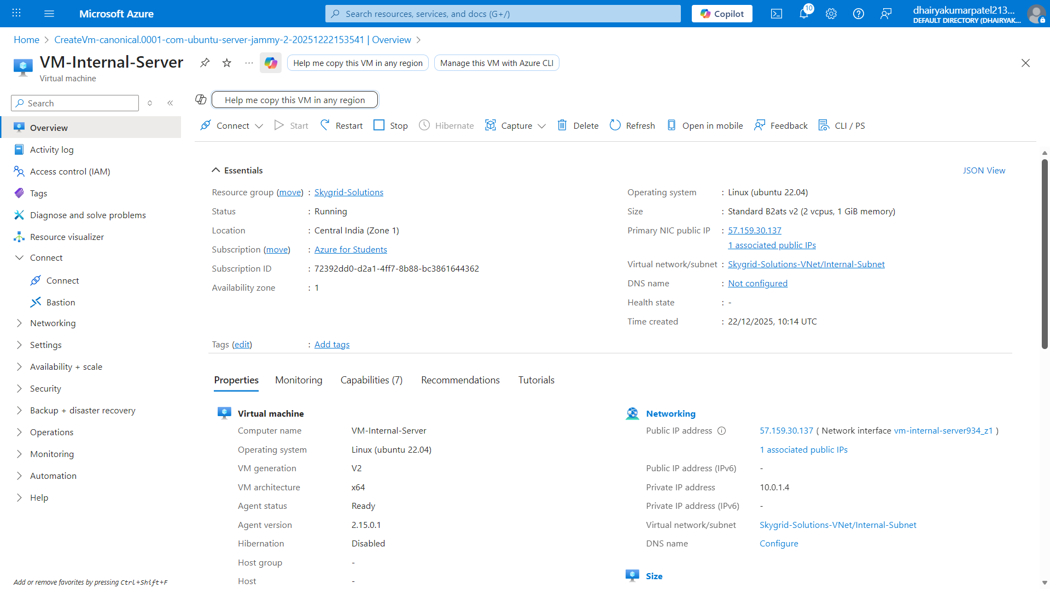

7.2 VM 2 – Web Server (DMZ)
Roles Implemented:
- Apache Web Server
- Static web page hosting
The web server generates:
- Access logs
- Error logs
This server represents an external-facing application server.
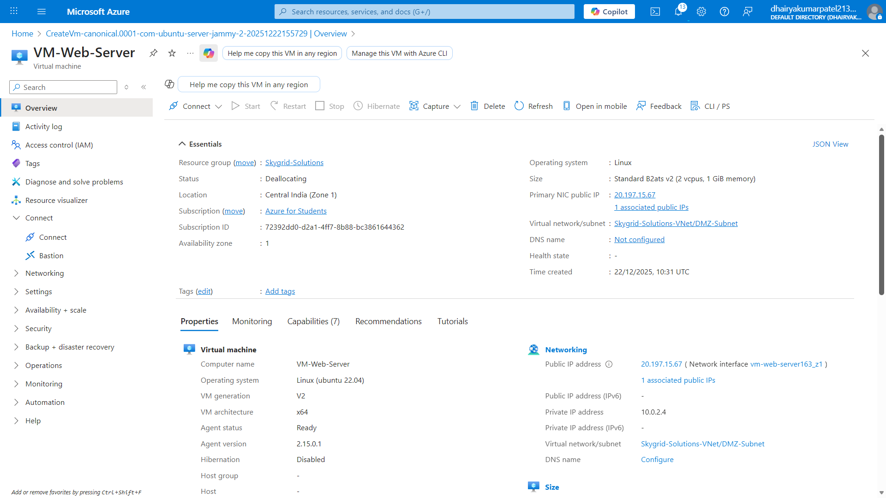

7.3 VM 3 – SIEM + Analyst Workstation
Roles Implemented:
- Wazuh SIEM
- Centralized log monitoring and analysis
This server acts as the Security Operations Center (SOC) workstation.
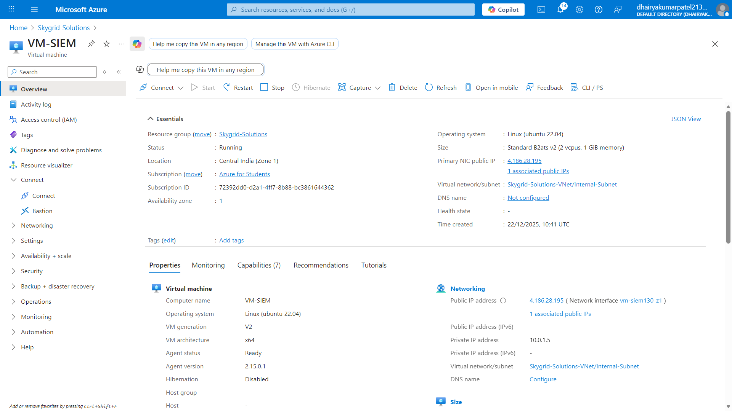

Basic Logging Configuration
Only default logging mechanisms were enabled.

8.1 Logs Generated

VM | Logs Generated
VM-Internal | Syslog, Authentication logs, Auditd
VM-Web | Apache access and error logs
VM-SIEM | Centralized collected logs

8.2 Log Forwarding
- Wazuh agents were installed on:
  - VM-Internal-Server
  - VM-Web-Server
- Logs were forwarded to:
  - VM-SIEM (Wazuh Manager)
⚠️ No firewall rules, SSH hardening, or security baselines were applied.
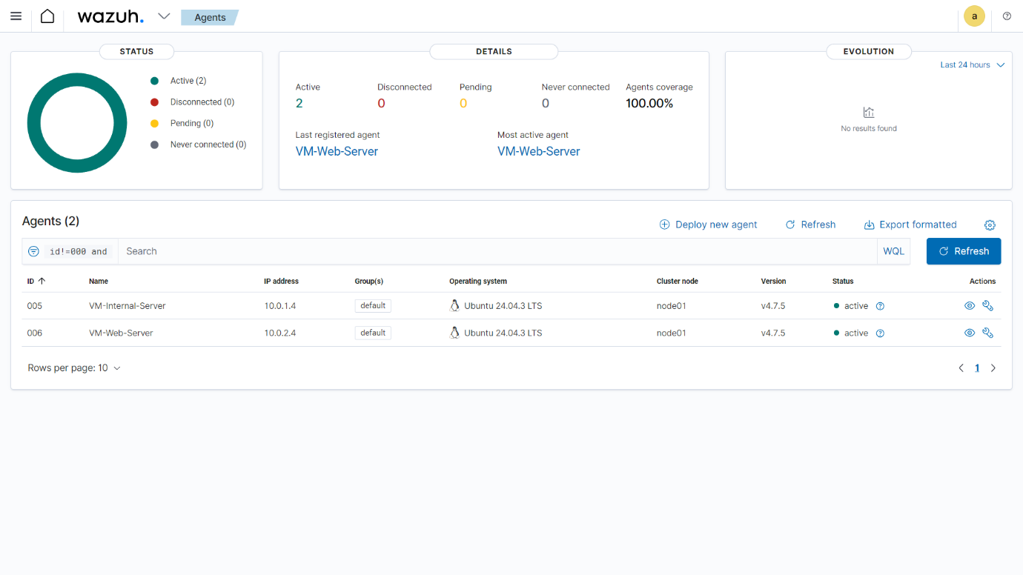
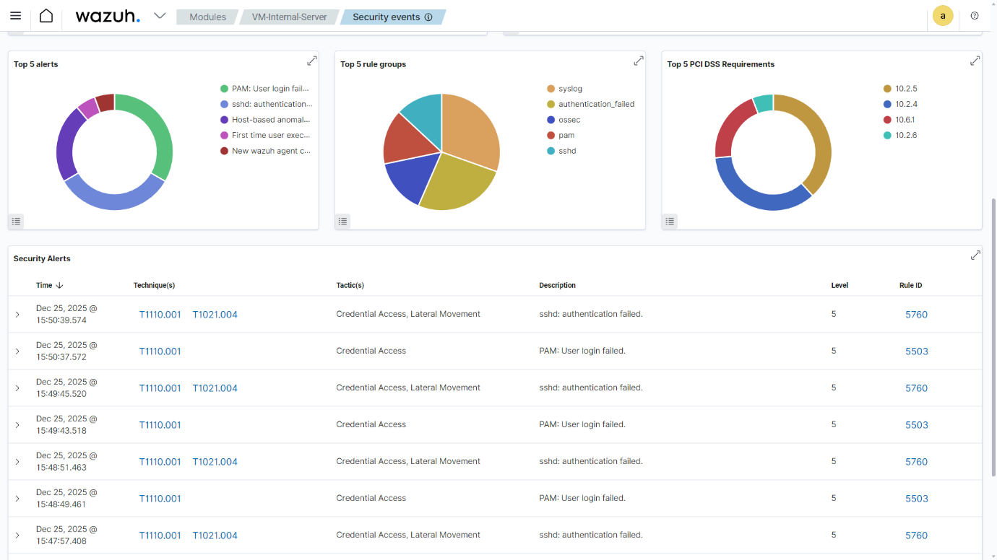
Wazuh SIEM dashboard displaying logs received from Internal and Web servers.

9. Network Diagram
A network diagram was created to represent:
- Virtual Network
- Subnets
- VM placement
- Traffic flow

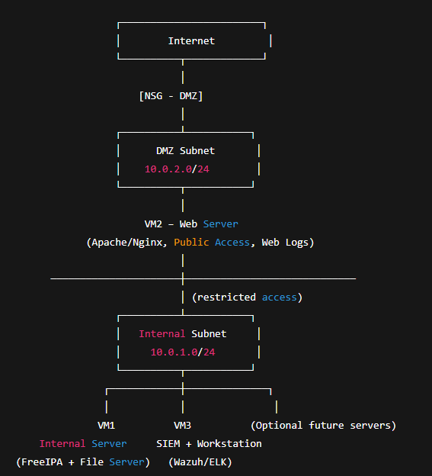

10. Deliverables Summary
The following deliverables were completed:
- Infrastructure Deployment Report
- Network Diagram
- VM Inventory
- Logging Summary
- Screenshot Proof with student name visible

11. Conclusion
This project successfully deployed a mini enterprise cloud infrastructure on Microsoft Azure with basic logging enabled.
The environment was intentionally left unsecured, fulfilling the requirement for future attack simulation, log analysis, and SOC operations in the Major Project phase.
Through this project, practical knowledge was gained in:
- Cloud infrastructure deployment
- Linux server roles
- Network segmentation
- Centralized logging using SIEM

Declaration
I declare that this project has been completed by me using my Azure Student Account, and all screenshots submitted clearly show my name and resource group as required.
Date: 22 Dec 2025

